Assessment on Javascript

- Add validations to the last assessment developed website Login and Registration page.
- Perform the CRUD operations on Student domain. Fields of Student domain are
- Student ID.
- Name
- Stream
- Marks

Display the student’s data in the table as given below.
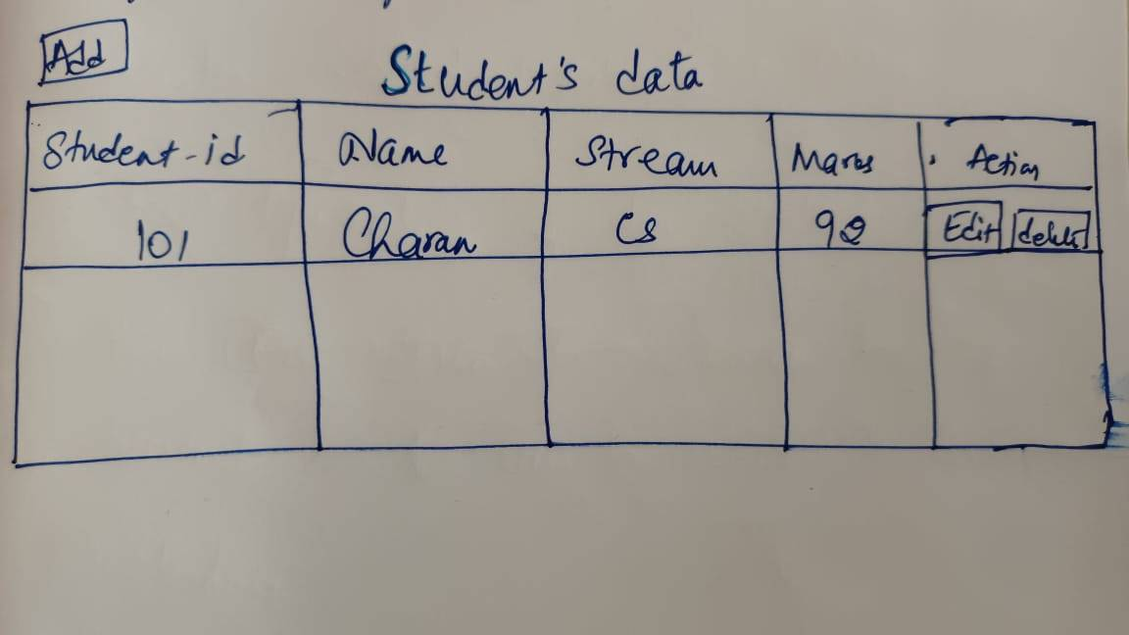

- When the user clicks on Add button, a new record should be added to the table. Edit should modify a record and update the table and delete should delete the record.

- If this assessment is already completed then add a search box at the top of the table. User can enter Student ID in this search box. After entering the data, user will click on Submit/Search button. Based on the entered data, table data should be filtered accordingly and should display the filtered data in the table.

- On click of clear button, search string is cleared and entire table data will be displayed.
